**Taoyuan Airport**

**Ubus:**

Airport 🡪 Taichung

Bus Terminal

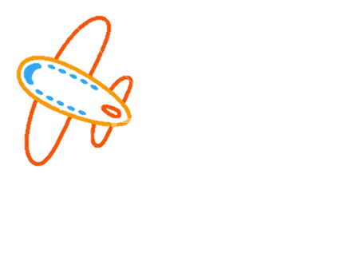



**Kuo-Kuang Bus**

Airport 🡪 Taichung

Bus Terminal

Taichung

Bus Terminal



**Taichung 101 Bus**

get off at *Indigenous Peoples Activity Center* station

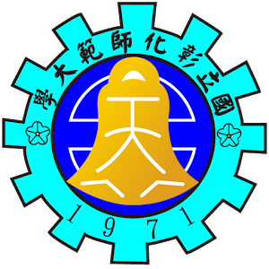

**Changhua Bus**

Changhua Train Station

🡪*Indigenous Peoples Activity Center* station

**Ubike:**

Changhua Train Station

🡪 NCUE



**Taxi: $120**

Changhua Train Station

🡪 NCUE



**Changhua Bus Stop**